Wastewater Prevention Document

All of this data that I am finding is older, we got to see if there are any new articles, they are mostly from 2010-2015

<https://www.npr.org/2014/10/29/359875321/as-infrastructure-crumbles-trillions-of-gallons-of-water-lost#:~:text=As%20Infrastructure%20Crumbles%2C%20Trillions%20Of%20Gallons%20Of%20Water%20Lost%20The,in%20the%20Chicago%20area%20alone>.

* Water infrastructure is getting older and starting to deteriorate and causing lots of water to be lost into the environment
* Estimate that 2.1 Trillion gallons of water lost per year in USA
  + Amount 14 to 18% of water treated is lost
* Other estimates are as high as 6 billion gallons of water per day in the US
* Iin LA in July 2014 a water main estimated to be 93 years old broke open causing severe flooding on the campus of UCLA
* CIty of Chicago area alone is losuign 22 billion gallons of treated water per year
  + That’s almost 700,000 people in a year that could be used for

<https://www.infrastructurereportcard.org/cat-item/drinking-water/>

* Estimated 240,000 water main breaks per year in the US
* The US uses 42 Billion gallons of water a day to support daily life
* Many of the pipes were laid in the early to mid 20 century with a life span of 75-100 years
* Nearly 6 billion gallons of water per day are lost
* Amount of water lost could support 15 million households
* Water consumption in the US dropped by 5% this decade for the first time in 40 years
  + Even though the population has increased by 70 million people over the same period

<https://www.cbc.ca/news/canada/city-water-leaks-wasting-millions-of-tax-dollars-1.1048035#:~:text=Millions%20and%20millions%20of%20litres%20could%20seep%20away%20unnoticed%20for%20years.&text=And%20they%20have%20%E2%80%94%20all%20across,35%20or%2045%20per%20cent>.

* “what if a municipal water pipe has a long, slow leak deep beneath the surface of the ground. Millions and millions of litres could seep away unnoticed for years. ”
* In some municipalities, there have been estimates of water loss as high as 34 or 45 percent.
* 2009 study said leaky pipes cost Ontario 25 percent of its drinking water – a loss of 700 million a year
* Some towns are working to methodically trying to figure out just how healthy their aging pipes and systems are, and they are trying to fix and fix leaks before they turn into more significant problems
* Key to that pratice is diving the area served by a utility into discrete areas and methodically tracking water flows to determine where leaks are. When leaks are identified, sometimes long before they might otherwise show up as gushers or ponds on streets, they are fixed
* In Halifax utility made to reduce leaks, the amount of water the system required was reduced from 168 million litres of water per day in 1999 to 130 million in 2011
* Pure Technologies
  + Created a robotic device tethered by a fibre-optic cable was also used to inspect the main
  + Pure Technologies charges $5 to 10 per metre of pipe instpected
  + A full condition could cost 60-80$ a metre
  + About 4% of the total capital replacement of the pipe in question
* Look down the road and see how failing to carefully manage water resources could start to limit a community’s sustainability

<https://www.cbc.ca/news/canada/toronto/leaky-pipes-cost-ontario-25-of-its-drinking-water-700m-a-year-1.838968>

* Ontario Taxpayers are shelling out $700 million a year for drinking water than never reaches their taps,
* The Residential and Civil Construction Alliance of Ontario says it found that municipal water systems in the province experience leakage rates ranging from 10 to 50 percent
* Estimates say that about ¼ of the drinking water in Ontario is pumped into the ground
  + About 327 million cubic metres of water
* Problems and costs associated with leaky pipes is
  + Cause basement flooding, erosion of foundations, service disruptions and in extreme cases, sink holes
  + Treated water contains chlorine, and this can flow into sensitive bodies of water
  + Leaky sewer lines result in effluent (poop) being discharged into the environment
* Fixing the pipes will not only help reduce the lost water but also the costs associated with cleaning and filtering and pumping it which all add up

<https://www.cbc.ca/news/technology/high-tech-detection-methods-help-municipalities-battle-leaky-water-mains-1.883212>

* In 2005 Ottawa lost more than 26 billion liters of water
* In 2009 got it down to 16 billion liters (about 15 percent of Ottawa water)
* 10 percent of water loss is considered acceptable in the industry
* They can either reduce water loss or water demand
* About 90% of leaks never reach the surface
* There are listening devices that can pinpoint their location within a metre or so, Campbell says that means they can solve the problem faster but they still have to wallk the line(pipe)
* Another solution is to divide the water system up into zones to measure the amount of water that can reach or travel to each zone to check for losses
* Only about 2/3 of water utilities in Canada even meter water as it leaves their systems
  + Can be costly and time consuming to add metering devices
* Even with new technology there is no clear quick fix to municipal water waste

<https://www.watercanada.net/great-lakes-wasted/#:~:text=More%20than%20580%20billion%20litres,released%20today%20by%20Environmental%20Defence>.

* More than 580 billion litres of drinking water is being lost in Ontario and Quebec every year
* Just talks about way to save the water uses, not really relevent

<https://www.watercanada.net/feature/watertight/>

* The average Canadian city isn’t doing much to fix water loss, says Echologics Engineering Inc
* Halifax Water, says it is always worth looking for leaks to repair, you be amazed by how much water you save by fixing them
* They monitor the water generally between 2 and 3 am since that is when the leaks will come up since there is minimal water flowing then
* Average leak runs between 6 and 8 months before it surfaces
* A lot of asset managers decide its cheaper to run a asystem with water loss than to replace a pipe.
* When they find a leak, they are able to let the home owners know they wont have water when repairing instead of just fixing it when it breaks

<https://www.rcinet.ca/en/2016/07/07/stopping-the-leaks-tax-money-and-leaking-municipal-pipes/>

* Noise loggers to monitor the liens to determine if there are leaks
* They found that they were 99.5 accurate when tyring to find the leak and within 1m

<https://www.aquadoc.ca/wp-content/uploads/2018/12/Canadian-Experience-Using-Leak-Detection-as-a-Key-Component-of-Municipal-Water-Loss-Control.pdf>

* Calgary is over 110 Noise correlation data loggers, followed up by specialized leak correlation operators and repair crews
* Water waste has become more urgent as a result of climate change induced water shortges and increased demand
* Three types of leak detection:
  + Biological-based
  + Hardware based
  + Softweare Based
* Leaks can be heard with listening devices, they are usually placed on fire hydrants that are placed about 150m apart in canada
  + It is easier to hear in metal small diamter pipes and larger or plastic or concrete pipes are hard to hear unless you are less than 5m away which doesn’t help the issue of finding the leak
* Hardware based systems use sensors to detect and locate leaks and include acoustic emission detectors, negative pressure detectors, fibre-optics sensors and ultrasonic and infrared technologies
* Software Based systems, there are many ways that they use like negative pressure waves, and pattern recognition but each of the approaches has specific strengths and weaknesses depending on the circumstances
* Mass Balance Method is the process of using live data and determiening the flow rates and losses to be able to help more quickly find the problem areas, the problem is that the areas are larger usually from where they have their loss data and thus can be harder to actually find the loss in the area
* Software and Computers can be used to detect differences or changes in flow patterns to determine if there is leaks anywhere along the system lines. It is often cheaper to do it with a comptuer since you are able to analyze the data later and don’t need to pay the high labour costs at night to inspect the lines
* Acoustic equipment is the main type of leak detection equipment used by the water industyr and is highly effective
  + Effectiveness depends on the experience of the operator
* Leak noise correlation is great but does not work well in newer plastic or concrete pipes
* There are currently a bunch of techniques to be used but it seems like part of the problem for why water companies are not going after it is the lack of budget to fix issues
* Calgary use one of two listening devices to determine the leaks and they cost between 1500 and 800$ to purchase
* “While there have been breakthroughs, Calgary still has challenges finding leaks in PVC pipe, which doesn’t leak often (usually a rolled gaskey), but when it fails, it usually dramatic and easy to find.”

Problem Statement:

Find the areas where leaks occur faster and more efficiently.

Locating leaks involves identifying and prioritizing the areas of leakage to make pinpointing leaks easier.

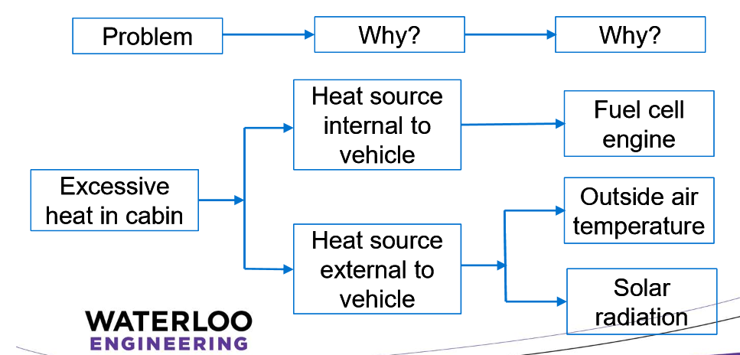

Problem:

* Excessive water loss from pipes between the water filtration plant

Why:

* Water Distribution Plants lousing water
* Leaky old pipes starting to become damaged
* Its costs utilities companies so much money in loss and extra chemicals